Newsletter
Oct 2021 Issue 26

7 Nations Participating
28 Clinical Sites Worldwide
618 Participants Screened (Inc longitudinal visits)

Dear HDClarity Teams,

Firstly, we would like to wish you all a Happy New Year and well wishes for 2022!! Last year was extremely challenging for many; however, the dedication of our clinical sites, and the determination of the HD community, ensured that HDClarity had a successful year and continues to facilitate therapeutic advances in Huntington’s disease.

Thank you to everyone for all your hard work, we have now completed 657 sampling visits, including longitudinal and optional repeat visits.

- Since the last newsletter (October 2021) our sites across the world have conducted 28 new screening visits, 28 sampling visits and 1 optional RPT sampling visit.
- Special thanks are given to GHI and Rome who continue to prioritise longitudinal recruitment. In total, we have now obtained longitudinal biosamples from 47 participants. This is a fantastic number, and we are confident that it will continue to rise!!
- We would like to congratulate Birmingham & Solihull Mental Health Trust for their successful restart following the UK COVID19 lockdown. We are excited for additional UK sites to reopen soon.

Given that a new year of HDClarity has begun, we have decided that this edition of the newsletter will review last year’s activities and provide key facts and figures concerning the advancement of HDClarity throughout the last 12 months.

New Clinical Sites

HDClarity Clinical Site Updates
Since the last newsletter, we completed a successful Site Initiation Visit with University College London and have added one new clinical site into HDClarity:

We would like to welcome Dr Coulthard and her team in Bristol into HDClarity. We are extremely happy to have you on board!!

The addition of Bristol takes our total number of UK sites to 12, and our total number of European sites to 21.
HDClarity CSF Collection
CSF represents a valuable source of biomarkers in HD. The primary goal of HDClarity is to generate a repository of high-quality biofluid samples, from which scientists around the world can request samples and conduct independent research. In total, 11.5 litres of spinal fluid have been collected. This is a phenomenal amount which we are incredibly proud of.

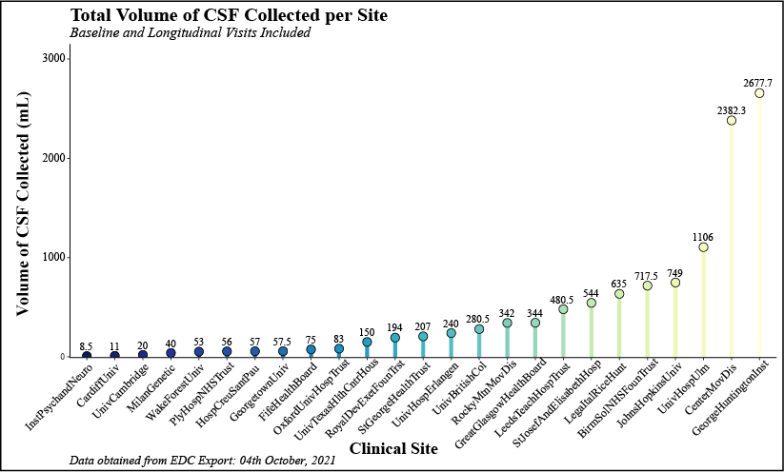
Additionally, most lumbar punctures have obtained the desired amount of CSF (20mL) and very few LPs have collected less than 15 mL. This highlights the outstanding expertise of all study teams who have worked extremely hard to ensure the success of HDClarity.
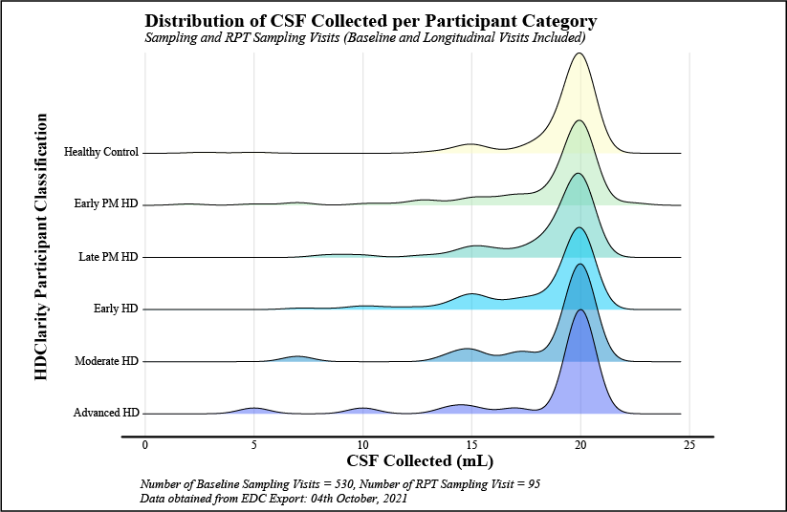
HDClarity Longitudinal Recruitment

Clinical sites operating on Protocol V3 can now invite participants back for longitudinal HDClarity visits. These visits must occur >11 months after the previous enrolment and are open to all participant categories.

Currently, we have 5 sites that have successfully completed a total of 39 longitudinal initial sampling visits (and 1 RPT sampling visit). We are encouraging our sites to prioritise longitudinal recruitment wherever possible, as the samples collected will provide valuable insight into the dynamics and prognostic potential of biomarkers derived from blood and CSF.

We value all our participants; however, a special thanks goes to a fantastic participant in Toronto who underwent 3 lumbar punctures during their time with HDClarity!! Thank you very much!!

REMINDERS
- All sites operating on Protocol V3 should attempt to prioritise longitudinal visits (if possible).
- All UK sites should contact CC when they intend to restart HDClarity. We shall provide you with detailed instructions on how to proceed.
- Following the collection of biosamples by the designated courier, it is important that the shipment notification on the EDC is completed accurately (e.g., quantity and type of samples, the study name, the site name/ID, the researcher who initiates the shipment, and the LabID), and matches the samples for which a shipment has been requested.
- Some or all your HDClarity biokits will have expired and CC will need to arrange replacements for these. Expired components may include:
  - Spinal needles – kits containing 22G Whitacre spinal needles should be replaced with new kits that include the 24G needle, introducer, and aspiration syringe.
  - Polypropylene pipette tips – these have expired in many CSF and blood processing kits.
  - Vacutainers – have expired in many blood collection kits.
  - Please notify HDClarity CC at least 14 days prior to a planned sampling visit and we will send replacements for the above. In the case of vacutainers, you may use a locally sourced replacement if you prefer, but please inform HDClarity CC of the replacement make and model and include a photo at least 7 days before the visit

Thank you.

Please contact UCL Central Coordination if you have any questions hdclarity-cc@enroll-hd.org

Study Manager: Gail Owen
Study Coordinators: Seema Maru, Kat Schubert
Study Research Assistant: Alex Lowe

